Unit #: 1
Unit Name: Problem Solving Fundamentals
Topic: Control Structures

Course objectives:
The objective(s) of this course is to make students
CObj1: Acquire knowledge on how to solve relevant and logical problems using computing machine
CObj2: Map algorithmic solutions to relevant features of C programming language constructs
CObj3: Gain knowledge about C constructs and it's associated eco-system
CObj4: Appreciate and gain knowledge about the issues with C Standards and it's respective behaviors
CObj5: Get insights about testing and debugging C Programs

Course outcomes:
At the end of the course, the student will be able to
CO1: Understand and apply algorithmic solutions to counting problems using appropriate C Constructs
CO2: Understand, analyse and apply text processing and string manipulation methods using C Arrays, Pointers and functions
CO3: Understand prioritized scheduling and implement the same using C structures
CO4: Understand and apply sorting techniques using advanced C contructs
CO5: Understand and evaluate portable programming techniques using preprocessor directives and conditional compilation of C Programs

Introduction
A program is nothing but the execution of sequence of one or more instructions. It is most of the time desirable to alter the sequence of the statements in the program depending upon certain circumstances or as per the logic. Involves decision making to see whether a particular condition has been met or otherwise and direct the computer to execute certain statements accordingly. Based on logic, it is becomes necessary to alter the flow of a program, test the logical conditions and control the flow of execution as per the selection of these conditions that can be placed in the program using decision-making statements

Control Structures
C programming language supports a few looping and a few selection structures. It may also support some unconventional control structures.
- Looping structures:
-while statement

-for statement
-do … while statement
- Selection structures/ Decission Making/ Conditional structures:
- Simple if Statement
- if – else Statement
- Nested if-else statement
- else if Ladder
- switch statement
- Unconditional structures:
- goto statement
- break Statement
- continue Statement
- return Statement

Looping
Let us start the discussion with the while statement. The while statement starts with the keyword while and is followed by an expression in parentheses and is followed by a statement or a block.

while(Expression)

{

Statement(s); // block

}
The expression of the while is evaluated. It could be non-zero or zero. If it is non-zero, the body of the while is executed and again the control comes back to the expression of the while. If the expression of the while is false, the loop is exited.

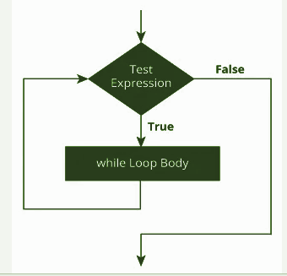
The loop evaluates the Test Expression inside the parentheses(). If Test Expression is TRUE, statements inside the body of while loop are executed. For looping to continue Test Expression has to be evaluated again as TRUE; terminated if the evaluation results in FALSE.
It is a good programming practice to always use a block even if only one statement is in the body of the loop. The body of the while loop is executed 0 or more times as the condition to be checked is at the top.

Coding Example_1: Display all the numbers from n to 0.
Version 1: Results in infinite loop as n remains to be 5 –>is always true
int n = 5;
while(n)
printf("%d ", n);
n= n -1;//control will never execute this statement

Version 2: Displays 5 4 3 2 1. But the program layout does not indicate the logic structure of the program. Always indent the code to indicate the logic structure
int n = 5; while(n){
printf("%d ", n);
n = n –1;}

Version 3: Indent the code. Always use the block.
int n = 5; while(n)
{
printf("%d ", n); // output : 5 4 3 2 1. This is nice.
n = n -1;
}

Version 4: Observe the value of n-- is the old value of n. When n is 1, the value of n becomes 0but the decrement operator returns 1.
int n = 5;
while(n)
{
printf("%d ", n--); // 5 4 3 2 1
}

Version 5: Pre-decrement operator returns the changed value.
int n = 5;
while(n)
{ printf("%d ", --n); // 4 3 2 1 0
}
Version 6: The expression of while acts like a sequence point.
int n = 5;
while(n--)
{
printf("%d ", n); // 4 3 2 1 0
}
Observe that the old value of n is used to check whether the condition is true or false and by the time, the body of the loop is entered, n would have the decremented value.

Version 7:
int n = 5;
while(--n)
{
printf("%d ", n); // 4 3 2 1
}
Compare the last two versions. In the first case, the loop is executed n times and in the second the loop is executed n –1 times. In the first case, the value of n is -1 and in the second case, it is 0.

Coding Example_2: Find the sum of numbers from 1 to n.
int n; // read n from the user
int i = 1; // initialization
int sum = 0;
while(i <= n) // condition
{
sum += i++; //equivalent to sum = sum + i
// modification
}

There is clearly some initialization, some processing and some modification at the end of the loop. In such cases, we may want to use the for statement.
// <for stmt>:: for(e1; e2; e3) <block>|<stmt>
// e1, e2, e3 : expressions
// e1 : initialization
// e2 : condition
// e3 : modification
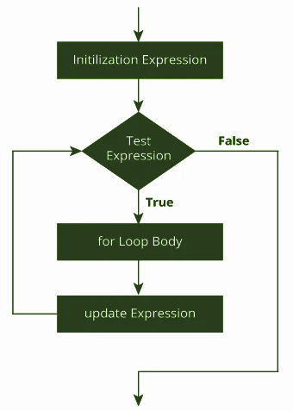
For loop in Detail:
e1 is executed once. e2 is checked for condition. If it is non-zero, execute the body of the loop and then execute e3. Again, check for e2and thus the process continues till e2 results in Zero Value. Once e2 is Zero, come out of the loop and execute the statement outside the body of the loop. for loop is also called as a pre-tested loop. The general structure of for loop syntax in C is
for (initial value; condition; increment or decrement )
{
statements;
}

Note: The semantics of for statement is same as the while statement.
Few questions to Answer:
- Can you have initialization outside the for loop and modification inside the body of the loop?
- Can you skip condition in for loop?
- Can you have only ;; in for loop?
Coding Example_2: What this code does? Why it is wrong?
int sum = 0;
// wrong code
for(int i = 1; i <= n; sum += i)
{
++i;
}
Observe closely. You will find that the summation starts from 2 and not from 1. We will also end up adding n + 1. Check the way a for statement executes.
int sum = 0;
for(int i = 1; i <= n; ++i)
{
sum += i;
}
‘C’ for statement is same as the ‘C’ while statement –we say they are isomorphic. It is a question of choice and style while writing programs in ‘C’.

Coding Example_3: Find what the digital root of a given number
The idea is to add the digits of a given number. If that sum exceeds a single digit, repeat the operation until the sum becomes a single digit. This is useful in parity checking.
for(s = 0; n; n /= 10)
{
s += n % 10;
}
This loop finds the sum of digits of n. The result is in s and n would have become 0. If s exceeds 9, we would like to copy s to n, repeat this operation.
Can we put this code under a while(s > 9) { <this code> }?
The answer is a NO as the value of s is not initialized until we enter the inner loop? Shall we initialize to 0? Then the loop itself is not entered. How about making s 10? Looks very unnatural. Can you realize here that the sum becomes available only after doing the summation once? We require in this case, a bottom tested looping structure which executes the code at least once
Here is the solution using do – while.
do
{ for(s=0; n; n/2)
{
s+=n%10
}
n=s;
}while(s>9);

do –while loop:
The body of do...while loop is executed at least once. For loop to continue, the test expression is evaluated for TRUE; terminated if the evaluation results in FALSE.

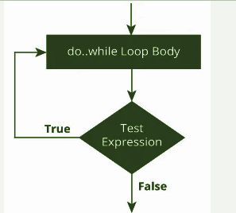

Selection statements
If the expression of if is true we execute the block following if, otherwise execute the else part if any. It is always preferred to use a block even if there is a single statement in the if and else portions.
//<if stat> ::= if (<expr>) <stat>|<block>
//<if stat>::= if (<expr>) <stat>|<block> else <stat>|<block>

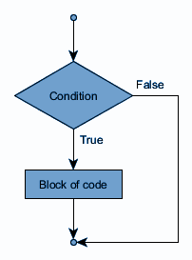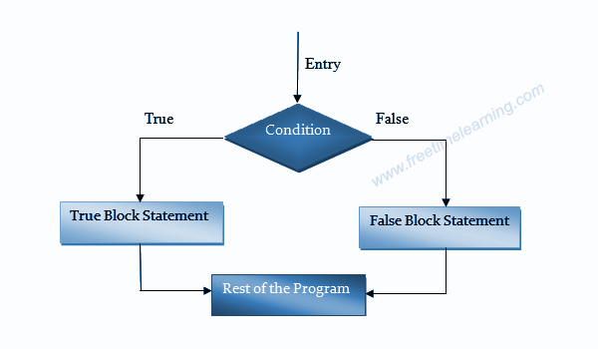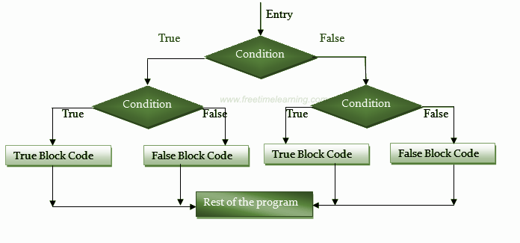

Coding Example_4: Classify triangles given the 3 sides as equilateral, isosceles or scalene. This is one possible solution.
int count = 0;
scanf("%d%d %d", &a, &b, &c);
if(a == b) ++count;
if(b == c) +count; if(c == a) +count;
if(count == 0) printf("scalene\n");
if(count == 3) printf("equi\n"); if(count == 1) printf("iso\n");
Compare every pair of sides and increment the count each time –initialized to 0 on start. Can the count be 2?

Observe a few points here.
● We are comparing integers (integral values)
● We are comparing a variable(an expression) with constants
● We are comparing for equality (no > or < )
● In all comparisons, the same variable is used.

In such cases, we may use switch statement.
switch(count)
{ case 0: printf("scalene\n"); break;
case 3: printf("equi\n"); break;
case 1: printf("iso\n"); break;
}
The value of count is compared with case clauses. This comparison decides the entry into the switch and not exit from there. To avoid the code fall through, we use break statement. The rule of ‘C’ is “break if switch”.
If we do not use the break statement, all statements after the matching label are also executed. These switch statements are more efficient compared to normal if statements. But can you include else part of if in switch case? -- Yes using default. But the default clause inside the switch statement is optional.
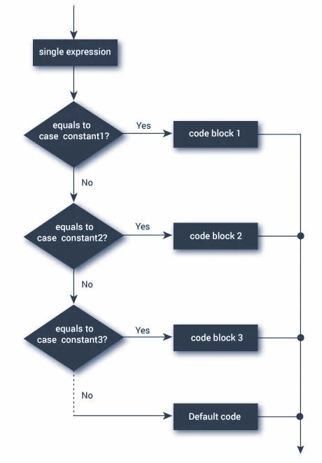
Coding Example_5: Inclusion of default in switch case to have the else facility
printf("enter three sides of a triangle\n");
int a,b,c;
scanf("%d%d%d",&a,&b,&c);
int count = 0;
if(a == b) count++;
if(b == c) count++;
if(c == a) count++;
switch(count)
{
case 1:printf("iso");break;
case 3:printf("equi");break;
case 0:printf("scalene");break;
default:printf("not a valid count");break;
}
printf("switch ended");

Few points to think!!
- Is it compulsory to have break for default?
- Can we have default at the beginning of the switch case?

Coding Example_6: The count value cannot be anything other than 0,1 or 2. So change in the default case as below.
switch(count)
{
case 1: printf("iso");break;
case 3: printf("equi");break;
default: printf("scalene");break;
}
printf("switch ended");

Coding Example_7: Find whether the entered character is a vowel or not.
#include<stdio.h>
int main()
{
printf("enter the character\n");
char ch;
ch = getchar();
//scanf("%c",&ch);
// solution using if
/*if(ch == 'a' || ch == 'e' || ch == 'i' || ch == 'o' || ch == 'u')
{
printf("you entered an vowel\n");
}
else{
printf("you did not enter the vowel\n");
}*/
// Solution using switch case
switch(ch)
{
//case 'a' || 'A': printf("hello 1"); break; // output of expression will be the case label
case 'a':
case 'A':
case 'e':
case 'E':
case 'i':
case 'o':
case 'u': printf("you entered an vowel\n");break;
default: printf("you did not enter the vowel\n");
}
// if(ch == 'a' || 'e'|| ) // Logical error
return 0;
}

Nested control structures
We may have loops and selections nested.

Coding Example_8: Generate all Armstrong numbers between 0 and 999.
The number obtained by raising each of the digits to the power of its length and adding together the sum of the terms obtained. If this sum is same as the given number, the number is same to be Armstrong.
Example: The three digit Armstrong number is 153. The sum of cubes of digits is same as the number. The program shows how not to write programs. We have a loop on hundredth digit, a loop on tenth digit and a loop on unit digit. We cube the digits, find the sum, form the number using these digits and compare the sum with the number formed.
#include<stdio.h>
int main()
{ int h,t,u,hc,tc,uc;
int number;
for(h = 0; h<10;h++)
{
for(t = 0; t< 10;t++)
{
for(u = 0;u< 10;u++)
{
hc = h*h*h;
tc = t*t*t;
uc = u*u*u;
int sum = hc+tc+uc;
number = h*100 + t*10 + u*1;
if(number == sum)
printf("%d\n",number);

}
}
}
return 0;
}
The above code is generating only few Armstrong numbers. Not printing all. Change the implementation to print all Armstrong numbers between 0 and 999. Think about adding ifs to check and count the number the digits

Also, think how many multiplications do we do for cubing? Should we repeatedly evaluate cube of t in the inner loop when it is not changing. Rearrange the code. Put the statements in the right blocks. You will be able to reduce the number of multiplications for cubing to approximately 1/3rd of what it is now.

Happy Coding!!

